First Name: __________________________ Last Name: _________________________________
Address: ____________________________________________________ Postal Code:________________
Home Phone: _________________________ Cell Phone: ______________________________
E-mail:___________________________________________ Confirmation: E-mail / Phone / Text
DOB (D/M/Y): _________/ _________ /_________ How do you identify:________________
Emergency Contact:_______________Relationship:_____________Phone:_____________________
Occupation:_______________________________ Ins Company:______________________________ Referred by?________________________________________
AHC # : ____________________________
X all apply: Musculo-Skeletal System Reproductive System Female:
☐Neck Pain ☐ Pregnant
Cardiovascular ☐Back Pain Due Date: _____________
☐High Blood Pressure ☐Hip Pain ☐C Section/Complications?
☐Low Blood Pressure ☐Shoulder/Arm/Hand Pain ____________________
☐Congestive Heart Failure ☐Leg & Foot Pain ☐Irregular Menstruation
☐Heart Attack ☐Headaches/Migraines ☐Menstruation Problems
☐Phlebitis/Varicose Veins ☐Herniated Disc
☐Stroke/CVA ☐Joint Stiffness/Swelling Other:
☐Pacemaker ☐Spasms/Cramps ☐Cancer
☐Broken/Fractures Bones Type: _______________
Respiratory: When: _______ Pins/Wires? ☐Depression
☐Chronic Cough ☐Strains/Sprains ☐Hearing Problems
☐Shortness Of Breath ☐Jaw Pain/TMJ ☐Vision Problems
☐Bronchitis ☐Tendonitis (Tennis/Golfers) ☐Diabetes
☐Asthma ☐ Bursitis Type: _______________
☐Emphysema ☐Arthritis Type: _______ ☐HIV/Hepatitis A/B/C
☐Chronic Obstructive ☐Osteoporosis ☐Herpes/Cold Sores
☐Pulmonary Disease ☐Scoliosis ☐Digestive Conditions
☐Whiplash ☐Ulcers
Nervous System: ☐MVA When: _________ ☐Sinus Problems
☐Numbness/Tingling ☐Fibromyalgia ☐Tuberculosis
☐Pinched Nerve ☐Chest/Ribs/Abdominal Pain ☐Tinnitus (Ear Ringing)
☐Insomnia ☐Anxiety/Stress
☐Chronic Fatigue Skin Conditions
☐Cerebral Palsy ☐Allergies: _____________ Have you received massage
☐Epilepsy/Seizures ☐Sensitivities: ___________ therapy before:
☐Multiple Sclerosis ☐Rashes Yes / No? When?
☐Muscular Dystrophy ☐Athletes Foot ____________________
☐Parkinson's Disease ☐Hemophilia/Anemia
☐ Bruise Easily
☐Psoriasis
☐Warts

Injuries or Surgeries within the last 5 years:
__________________________________________________________________
__________________________________________________________________
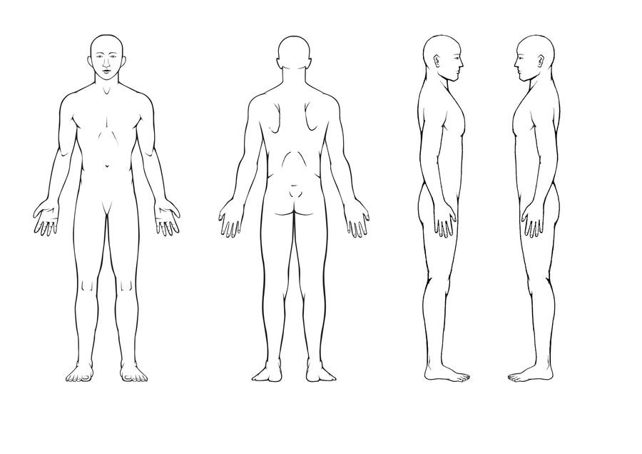
Please Mark areas of discomfort:
Are you currently taking any medications or
Supplements:_________________________________________________________________________________
Do you have any medical conditions not listed above? If yes, please describe: __________________________________________________________________________________________

Informed Consent
I have completed this health form to the best of my knowledge and have disclosed all medications, vitamins and minerals that I am currently taking. I agree to keep the massage therapist updated to any changes in my medical history, including mental, emotional and physical health, and further understand that the massage therapist is not liable.
I understand that the professional treatment I receive is for the purpose of improving, restoring, and/or maintaining my personal health. I Further understand that massage therapists do not diagnose illness or disease, prescribe medication or make spinal adjustments.
I understand there is potential for mild side effects with massage therapy, including but not limited to: Muscle soreness (lasting 24-48 hours), lightheadedness, slight inflammation, increased need for urination and nasal congestion I understand that massage therapy is not a substitute for medical examination, diagnosis, or treatment and recommended that I am working in conjunction with my primary caregiver for any condition that i may have. This information will be kept confidential unless required by law or after I have given consent to release information
Client Signature: __________________________________ Date: _______________
Parent/Guardian Signature: ___________________________ Date: _______________
Therapist Signature:_________________________________ Date: _______________
CANCELLATION POLICY
I _______________________ understand by initialing below I agree and recognize that a minimum of 24 hours notice is required to cancel appointments. Missed appointments without notice will be subject to a missed appointment fee equal to that of your scheduled appointment time. An appointment is considered missed if you arrive more than 15 minutes late. In addition, please understand that most insurance companies will not reimburse for missed appointments

Initial here ____________

