Manual Osteopath Intake Form
First Name: __________________________ Last Name: _________________________________
Address: __________________________________________________________________________
Home Phone: _________________________ Cell Phone: ______________________________
E-mail: ___________________________________ Confirmation: E-mail / Phone / Text
DOB (D/M/Y): _________/ _________ /_________ How do you identify: ________________
Emergency Contact:_______________Relationship:_____________Phone:_____________________
Occupation:_______________________________ Ins Company:______________________________ Referred by?_____________________ AHC # : ____________________________
Please fill out the intake form to the best of your knowledge. You’re more than welcome to add any additional information that may not be on the intake.
Have you had manual osteopathic treatment before? Yes No
Have you consulted a Chiropractor, Acupuncturist or Physical Therapist about the condition that you are currently seeking treatment? Yes No
Main Concerns:
1. ________________________________________________________________________________
2. ________________________________________________________________________________
3. ________________________________________________________________________________
Family Medical History: _______________________________________
Mother’s side: Father’s side: _______________________________________
Do you have any injuries or any past injuries? Please explain: _________________________________
____________________________________________________________________________________
____________________________________________________________________________________
Medications / Supplements / Vitamins - Please list any that you are currently taking and reason for use:
____________________________________________________________________________________
____________________________________________________________________________________
Do you have any allergies? Please list and explain what the reaction to them is:
____________________________________________________________________________________
____________________________________________________________________________________
Lifestyle:
Do you participate in any physical activities? Please describe:
____________________________________________________________________________________
____________________________________________________________________________________

What do you do to relax and alleviate stress:
____________________________________________________________________________________
____________________________________________________________________________________
What are the many causes of stress in your life?
____________________________________________________________________________________
____________________________________________________________________________________

Dietary Information:
Do you eat breakfast? Yes No
How much water do you drink each day? _________________
How many servings of fruit and vegetables do you eat each day? _________________
Alcohol: ______________ (# / week) Coffee/Tea: _____________ (# / week)
Pop: ______________ (# / week) Tobacco: ____________ (# / week) How is your appetite? ____________
Do you crave certain foods? ___________________________
Any unusual tastes in the mouth? ________________________

Circle the answer and explain (dates, procedures, etc.) in the space below:
Yes No Have you ever been in a car accident?
Yes No Have you ever experienced a hard fall onto your back or buttocks?
Yes No Have you ever experienced a hard blow to your head or a concussion?
Yes No Have you ever had any Surgical procedure?
Yes No Do you have a pin, plate, screw or other implant in your body?

Women’s Health
Are you currently pregnant? Y / N
Is your period painful? Y / N Is your period regular? Y / N
Do you experience low back pain? Y / N Any other symptoms? _______________________
Length of monthly cycle (Days): _____ Average length of period and flow (Days): _______
Do you get regular Pap smears? Y / N Date of last Pap smear: ______________________
Are you menopausal? Y / N If yes, date of last period: _____________________

Current forms of contraception:
Do you experience vaginal infections? Never Rarely Frequently
Do you experience bladder infections? Never Rarely Frequently
No. of pregnancies: ____ Births: ________ Miscarriages: _______ Abortions: _____ C-Sections _______

Men’s Health
Do you have regular screening tests done (blood work, prostate exam)? Y / N
Date of last prostate exam? _______________
What are the results of the prostate exam? ___________________________________________
Do you have difficulty urinating completely? Y / N
Do you feel any burning or pain while urinating? Y / N
How many times do you get up from your sleep to go to the bathroom at night? ______________

Pain:
Please clearly mark any areas of pain:
Key: XXX - Pain / OOO - Tingling / NNN - Numbness / SSS - Stabbing

Does anything make the pain worse?
____________________________________________________________________________________

Does anything alleviate the pain?
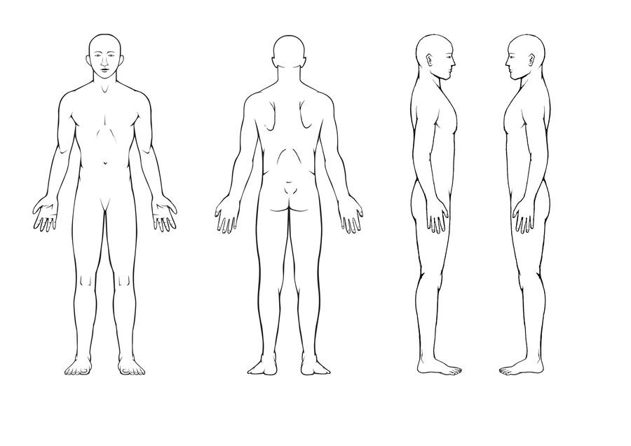
____________________________________________________________________________________

Do you have any of the following conditions?
☐Diabetes ☐Heart Disease ☐Cancer
☐Hepatitis ☐High / Low Blood Pressure ☐Tumor
☐Stroke / CVA ☐Epilepsy (Type) ____________ ☐Headaches / Migraines
☐Anxiety ☐Depression ☐Mental Issues ________________
☐Tuberculosis ☐Arthritis (Type) ____________ ☐STDs
☐Fibromyalgia ☐Osteoporosis
☐Skin Condition ________________________________________________________________
☐Any other Conditions? ____________________________________________________________

INFORMED CONSENT TO OSTEOPATHIC MANUAL TREATMENT
I understand that the Osteopathic Manual Practitioner is providing osteopathic manual therapy within their scope of practice.
I hereby consent to my Osteopathic Manual Practitioner to treat me with Osteopathic manual therapy for the above noted purposes including such assessments, examinations and techniques, which may be recommended by my Osteopathic Manual Practitioner.
I understand that treatments include manual therapies where the Osteopathic Manual Practitioners places his/her hands on your body. Many techniques will involve contact between your body and the Osteopathic Manual Practitioners body. Body and hand contact may include areas of your chest wall, pelvic floor, and pubic bones. If intra-oral work is required, disposable latex or vinyl gloves will be worn.
I understand that the osteopathic Manual Practitioner may ask you to remove some items of clothing in order to facilitate treatment. If you do not feel comfortable with any part of the treatment, please tell us immediately. The techniques can be discontinued or modified to be comfortable for you.
I acknowledge that no assurance or guarantee has been provided to me as to the result of the treatment. I acknowledge that with any treatment there can be risks and those risks have been explained to me and I assume those risks.
I acknowledge and understand that the Osteopathic manual Practitioner must be fully aware of my existing medical conditions. I have completed my medical history form as provided by my Osteopath Manual Practitioner and have disclosed to the Osteopathic Manual Practitioner all of those medical conditions affecting me. It is my responsibility to keep the Osteopathic Manual Practitioner updated on my medical history. The information I have provided is true and complete to the best of my knowledge.
I authorize my Osteopathic Manual Practitioner to release or obtain information pertaining to my condition(s) and/or treatment to/from my other caregivers or third party payers.
I have read the above noted consent and I have had the opportunity to question the contents and my therapy. By signing this form, I consent and I have the opportunity to question the contents and my therapy. By signing this form, I confirm my consent to treatment and intended this consent to cover the treatment discussed with me and such additional treatments as proposed by my Osteopathic Manual Practitioner from time to time, to deal with my physical, emotional, and mental conditions and for which I have sought treatment.

CANCELLATION POLICY

Patients are required to provide 24 hour notice for any cancellation. That time has been reserved for you and we appreciate having adequate time to fill the spot. The clinic reserved the right to charge the full fee for a missed appointment or an appointment cancelled with less than 24 hour notice.
Thank you for respecting our time. INITIAL _________

DATE: ____________________ SIGNATURE: _____________________________

