First Name: __________________________ Last Name: _________________________________
Address: ___________________________________________ Postal Code: ___________________
Home Phone: _________________________ Cell Phone: ______________________________
E-mail: ___________________________________ Confirmation: E-mail / Phone / Text
DOB (D/M/Y): _________/ _________ /_________ How do you identify:______________
Emergency Contact:_______________Relationship:_____________Phone:_____________________
Occupation:_______________________________ Employer:_____________________________
Ins Company:______________________________ Referred by?____________________________
AHC # : ____________________________
New Patient Intake Form
Please fill out the intake form to the best of your knowledge. You’re more than welcome to add any additional information that may not be on the intake.

Have you had acupuncture before? Yes No

Have you consulted a physician/dentist about the condition that you are currently seeking treatment? Yes No

Main Concerns:
- __________________________________________________________________
- __________________________________________________________________
- __________________________________________________________________
Past Medical History:
- __________________________________________________________________
- __________________________________________________________________
- __________________________________________________________________
Family Medical History:
Mother’s side: _______________________________________________________________________
Father’s side: _______________________________________________________________________

Have you ever been hospitalized or had any operations? Please explain:
_____________________________________________________________________________________________________________________________________________________________________________________________________________________
Do you have any injuries or any past injuries? Please explain:
_____________________________________________________________________________________________________________________________________________________________________________________________________________________

Medications / Supplements / Vitamins - Please list any that you are currently taking and reason for use:
_____________________________________________________________________________________________________________________________________________________________________________________________________________________

Do you have any allergies? Please list and explain what the reaction to them is:
_____________________________________________________________________________________________________________________________________________________________________________________________________________________

Pain:
Please clearly mark any areas of pain:
Key: XXX - Pain / OOO - Tingling / NNN - Numbness / SSS - Stabbing

Does anything make the pain worse?
_______________________________________________________________________

What helps alleviate this pain?
_______________________________________________________________________
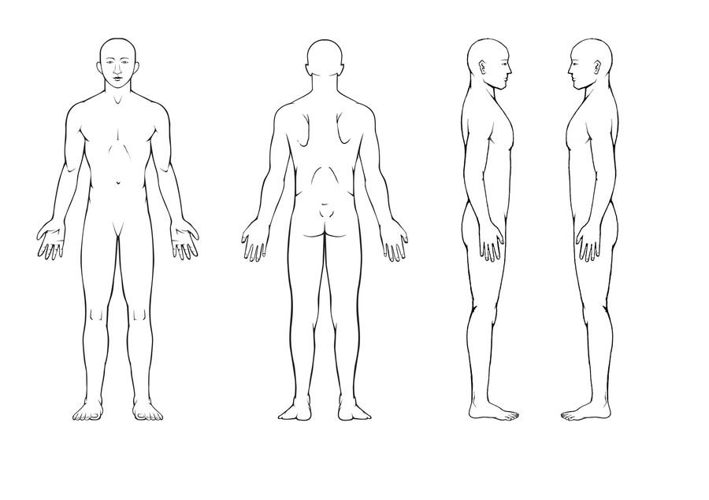

Lifestyle:
Do you participate in any physical activities? Please describe:
__________________________________________________________________________________________________________________________

What do you do to relax and alleviate stress:
__________________________________________________________________________________________________________________________

What are the many causes of stress in your life?
__________________________________________________________________________________________________________________________

Dietary Information:
Do you eat breakfast? Yes No
How much water do you drink each day? _______________
How many servings of fruit and vegetables do you eat each day? _________________
Alcohol:___ (# / week) Coffee/Tea: ___ (# / week) Pop: ___ (# / week) Tobacco: ___ (# / week)
How is your appetite? ________________________________
Do you crave certain foods? ___________________________
Do you feel thirsty often? _____________________________
Any unusual tastes in the mouth? _______________________

Sleep: Heart: Skin & Hair: Lungs:
How many hours of sleep ☐ High blood pressure ☐ Itchy skin ☐ Shortness of breath
do you get at night? _____ ☐ Low blood pressure ☐ Dry skin ☐ Chest tightness
☐ Insomnia ☐ Chest pains ☐ Oily skin ☐Chest oppression
☐Nightmares ☐ Palpitations ☐ Rashes ☐ Asthma/wheezing
☐ Waking tired ☐ Fainting ☐ Hives ☐ Chronic Cough
☐ Waking frequently ☐Irregular heart beat ☐ Ulcerations ☐ Dry cough
☐ Dream disturbed sleep ☐ Fast heart beat ☐ Eczema ☐ Cough with phlegm
☐ Problems staying asleep ☐ Slow heartbeat ☐ Psoriasis ☐Other:_________
☐ Problems falling asleep ☐ Feel light headed ☐Shingles
☐ Other:_________ ☐ Phlebitis ☐ Acne
☐ Orthostatic hypotension ☐ Fungal Infections
☐ Other:____________ ☐ Hair loss
☐ Brittle hair
☐ Premature greying
☐Other:________

Head, Eyes, Ears, Nose & Throat: Gastrointestinal: Genito-Urinary:
☐ Glaucoma # of bowel movements/day ___ ☐ Frequent urination
☐ Cataracts ☐Constipation ☐Scanty urination
☐Poor vision ☐ Diarrhea ☐Painful urination
☐ Night blindness ☐ IBS ☐ Burning urination
☐ Blurred vision ☐ Ulcerative colitis ☐ Cloudy urination
☐ Eye strain ☐ Colitis/enteritis ☐Urination at night
☐ Red eyes ☐ Hard stools ☐Retention of urine
☐Itchy eyes ☐Loose stools ☐Incontinence
☐ Spots in eyes ☐ Black stools ☐ Dark yellow urine
☐Floaters in eyes ☐ Mucus in stools ☐Light yellow urine
☐Poor hearing ☐Blood in stools ☐ Clear urine
☐Ringing in ears ☐ Vomiting ☐Frequent bladder infections
☐ Earaches ☐Nausea ☐Frequent kidney infections
☐Sinus problems ☐Gas ☐Other:________
☐Nosebleeds ☐ Bloating after meals
☐Swollen glands ☐ Undigested food in stool Do you suffer from any
☐ Lumps in throat ☐ Acid regurgitation of the following:
☐ Sore throat ☐ Gastritis ☐ Anxiety
☐ Dry mouth ☐Stomach cramps ☐Irritability
☐ Clears throat often ☐ Intestinal cramps ☐ Easily stressed
☐ Tongue sores ☐Hemorrhoids ☐ Depression
☐ Gum disease ☐ Other:________ ☐Poor memory
☐ Sore gums ☐Seizures
☐Bleeding gums ☐ Tics
☐ Cold sores Male Specific: ☐Abuse survivor
☐ Problems with TMJ Do your or have you experienced:
☐Grinding teeth ☐Erectile dysfunction
☐ Soft teeth ☐Premature ejaculation
☐ Multiple cavities ☐ Prostatitis
☐ Testicular trauma
☐Low Libido
☐ High Libido
☐ Nocturnal emissions ☐History of steroid use
☐ Dizzy/tired after ejactulation ☐ STI: ____________
☐Varicocele (Repaired?) ☐ Exposure to pesticides/
☐Hernia (Repaired?) chemicals

Consent for treatment

I, ____________________________________________, do hereby voluntarily consent to be treated with Acupuncture, at Purity Health and Wellness, #101 - 1006 103A street SW, Edmonton, Alberta.

I understand that Acupuncture is performed by the insertion of needles through the skin, and/or by the application of heat to the skin at certain points on or near the surface of the body. Acupuncture attempts to restore normal physiological body functions, modify or prevent pain perception.

I understand that with Acupuncture treatment there are some very slight risks and I have been made aware that certain adverse side effects may result. These include, but are not limited to: local bruising, minor bleeding, temporary pain or discomfort, fainting, and possible aggravation symptoms.

I understand that Acupuncture has been practiced safely for centuries. I also understand that no guarantees concerning its use and effects are given to me and that I am free to discontinue treatment at any time. I have had the opportunity to discuss the nature and purpose of therapies mentioned above.

I have read the above consent. I have also had the opportunity to ask questions about its content, and by signing below, I agree to the above modalities of treatment.

____________________________________________________________
Client Name Client Signature Date

____________________________________________________________
Guardian Name Parent / Guardian Signature Date

CANCELLATION POLICY

A minimum of 24 hours notice is required to cancel appointments. Missed appointments without notice will be subject to a missed appointment fee equal to that of your scheduled appointment time. An appointment is considered missed if you arrive more than 15 minutes late. In addition, please understand that most insurance companies will not reimburse for missed appointments.

