Chiropractic Intake Form

First Name: __________________________ Last Name: _________________________________
Address: _____________________________________________________ Postal Code: _______________
Home Phone: _________________________ Cell Phone: ______________________________
E-mail: ___________________________________ Confirmation: E-mail / Phone / Text
DOB (D/M/Y): _________/ _________ /_________ How do you identify: ___________________
Emergency Contact:_______________Relationship:_____________Phone:_____________________
Occupation:_______________________________ Employer:_____________________________
Ins Company:______________________________
​​Are you currently a student? Yes___ No___
Is there a chance you could be pregnant? Yes__ No__
Is this related to a motor vehicle accident? Yes___ No___
If yes, date of accident: ___________________________
Is this related to a workplace injury (WCB claim) Yes ____ No ____

Who can we thank for referring you to our office? __________________________ If you were not referred by a friend or family, how did you hear about our office? _______________
Have you been to a Chiropractor before? YES NO
If Yes, who _______________ When was your last visit? _________
Do you wear orthotics or special shoe inserts? YES NO If yes, how old are they? ____
Have you received imaging in the past 2 years? YES NO

Specific Concern History
Reason for today’s visit: Wellness Check-up or Specific Concern
Please describe your primary concern: _________________________
When did this problem begin? ______________________
How frequent is this problem? Constant Daily Weekly Other:_________ How has it progressed recently? Same Improving Getting Worse
Describe the pain: Sharp Burning Dull Stabbing Numbness Tingling Aching Throbbing Other:__________
Does the pain radiate: YES NO If yes, where? ___________
On a scale of 1 (no pain) to 10 (severe pain), rate your pain: ___ average____ at best___ at worst
What aggravates this problem: __________________________________________
Have you experienced a similar problem in the past? Yes No When:___________
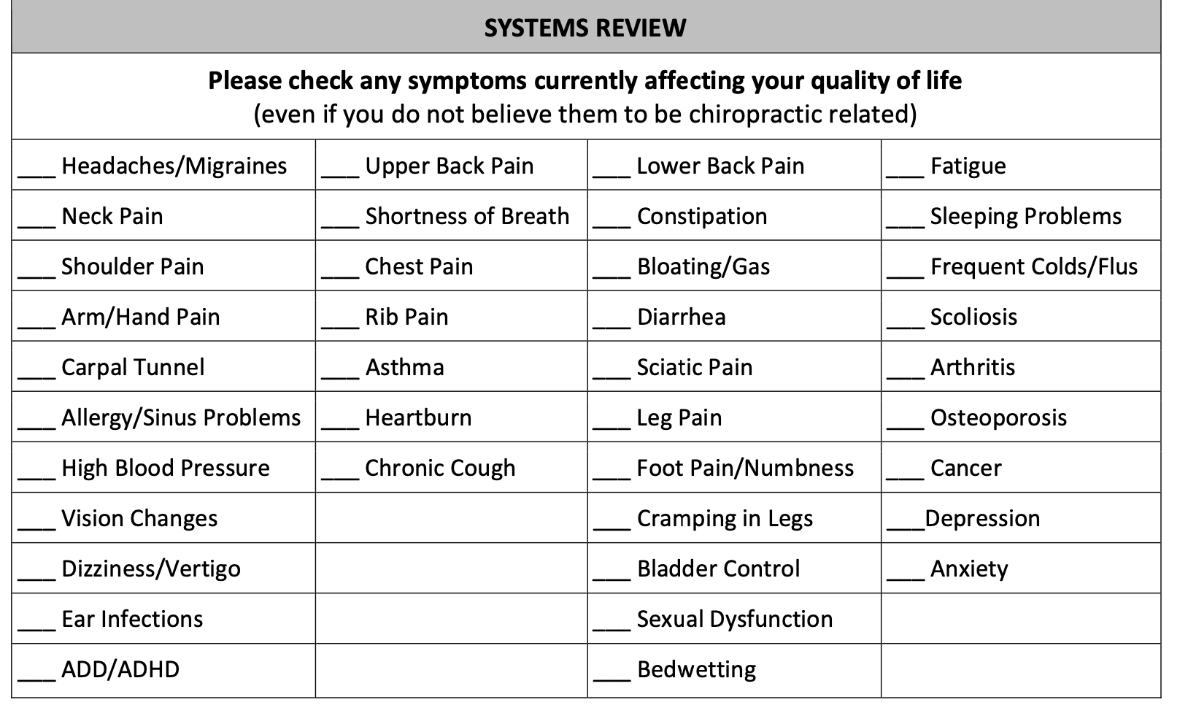
Is there a family history of: (circle all that apply)
Heart Disease Stroke Cancer Diabetes Other: __________
Please list any medications or vitamins you are currently taking and reason for taking:
_________________ _____________________
__________________ _____________________
__________________ _____________________

List any surgeries you have had and include when:
______________________ ___________________
____________________ __________________

CANCELLATION POLICY

By signing below you agree and recognize that a minimum of 24 hours notice is required to cancel appointments. Missed appointments without notice will be subject to a missed appointment fee equal to that of your scheduled appointment time. An appointment is considered missed if you arrive more than 15 minutes late. In addition, please understand that most insurance companies will not reimburse for missed appointments.

___________________________________________________________________
Client Name Client Signature Date

___________________________________________________________________
Guardian Name Parent / Guardian Signature Date

CANADIAN CHIROPRACTIC PROTECTIVE ASSOCIATION CONSENT TO CHIROPRACTIC TREATMENT

It is important for you to consider the benefits, risks and alternatives to the treatment options offered by your chiropractor and to make an informed decision about proceeding with treatment.

Chiropractic treatment includes adjustment, manipulation and mobilization of the spine and other joints of the body, soft-tissue techniques such as massage, and other forms of therapy including, but not limited to, electrical or light therapy and exercise.

Benefits
Chiropractic treatment has been demonstrated to be effective for complaints of the neck, back and other areas of the body caused by nerves, muscles, joints and related tissues. Treatment by your chiropractor can relieve pain, including headache, altered sensation, muscle stiffness and spasm. It can also increase mobility, improve function, and reduce or eliminate the need for drugs or surgery.
Risks
The risks associated with chiropractic treatment vary according to each patient’s condition as well as the location and type of treatment.

The risks include:
● Temporary worsening of symptoms – Usually, any increase in pre-existing symptoms of pain or stiffness will last only a few hours to a few days.
● Skin irritation or burn – Skin irritation or a burn may occur in association with the use of some types of electrical or light therapy. Skin irritation should resolve quickly. A burn may leave a permanent scar.
●Sprainorstrain–Typically,amuscleorligamentsprainorstrainwillresolveitselfwithinafewdaysorweeks with some rest, protection of the area affected and other minor care.
● Rib fracture – While a rib fracture is painful and can limit your activity for a period of time, it will generally heal on its own over a period of several weeks without further treatment or surgical intervention.
● Injury or aggravation of a disc – Over the course of a lifetime, spinal discs may degenerate or become damaged. A disc can degenerate with aging, while disc damage can occur with common daily activities such as bending or lifting. Patients who already have a degenerated or damaged disc may or may not have symptoms. They may not know they have a problem with a disc. They also may not know their disc condition is worsening because they only experience back or neck problems once in a while.
Chiropractic treatment should not damage a disc that is not already degenerated or damaged, but if there is a pre-existing disc condition, chiropractic treatment, like many common daily activities, may aggravate the disc condition.
The consequences of disc injury or aggravating a pre-existing disc condition will vary with each patient. In the most severe cases, patient symptoms may include impaired back or neck mobility, radiating pain and numbness into the legs or arms, impaired bowel or bladder function, or impaired leg or arm function. Surgery may be needed.

● Stroke – Blood flows to the brain through two sets of arteries passing through the neck. These arteries may become weakened and damaged, either over time through aging or disease, or as a result of injury. A blood clot may form in a damaged artery. All or part of the clot may break off and travel up the artery to the brain where it can interrupt blood flow and cause a stroke.

Many common activities of daily living involving ordinary neck movements have been associated with stroke resulting from damage to an artery in the neck, or a clot that already existed in the artery breaking off and travelling up to the brain.

Chiropractic treatment has also been associated with stroke. However, that association occurs very infrequently, and may be explained because an artery was already damaged and the patient was progressing toward a stroke when the patient consulted the chiropractor. Present medical and scientific evidence does not establish that chiropractic treatment causes either damage to an artery or stroke.

The consequences of a stroke can be very serious, including significant impairment of vision, speech, balance and brain function, as well as paralysis or death.

Alternatives
Alternatives to chiropractic treatment may include consulting other health professionals. Your chiropractor may also prescribe rest without treatment, or exercise with or without treatment.
Questions or Concerns
You are encouraged to ask questions at any time regarding your assessment and treatment. Bring any concerns you have to the chiropractor’s attention. If you are not comfortable, you may stop treatment at any time.

Please be involved in and responsible for your care. Inform your chiropractor immediately of any change in your condition.

DO NOT SIGN THIS FORM UNTIL YOU MEET WITH THE CHIROPRACTOR
I hereby acknowledge that I have discussed with the chiropractor the assessment of my condition and the treatment plan. I understand the nature of the treatment to be provided to me. I have considered the benefits and risks of treatment, as well as the alternatives to treatment. I hereby consent to chiropractic treatment as proposed to me.

____________________________________ Name (Please Print)

________________________________ Signature of patient (or legal guardian) Date_______20_

_______________________________ Signature of Chiropractor Date:_______20____

CANADIAN CHIROPRACTIC PROTECTIVE ASSOCIATION INFORMED CONSENT FOR ACUPUNCTURE CARE

It is important for you to consider the benefits and risks and alternatives to the acupuncture treatment offered by your chiropractor and to make an informed decision about proceeding with treatment.
Acupuncture involves the insertion of small sterilized needles into specific locations on the skin surface. Other procedures related to acupuncture include moxibustion, cupping and electroacupuncture.
Benefits: Acupuncture and procedures related to acupuncture have been demonstrated to be a safe and effective form of treatment for a range of conditions including musculoskeletal complaints and pain.
Risks: The risks associated with acupuncture include minor bleeding and bruising, temporary pain and soreness, nausea, fainting,burns, infection, shock, convulsions, pneumothorax, perforation of internal organs, and stuck or bent needles.

Please inform the chiropractor if you:
- Have or develop any major health issues
- Are pregnant or actively trying to be
- Have been fitted for a pacemaker or other electrical implants
- Have a bleeding disorder or take anticoagulants
- Have damaged heart valves or have a high risk of infection
- Suffer from metal allergies
- Are Immune compromised
- Have had prosthetic implants

Only sterile single use disposable needles will be used. All acupuncture needles are properly disposed of after each and every treatment.
Pregnancy: The use of certain acupuncture points and treatment techniques may not be recommended during pregnancy. Advise your chiropractor if you are pregnant or actively trying to be.
Alternatives: Alternatives to acupuncture treatment may include rest, exercise, other modalities or consulting other health professionals.
Questions or Concerns
You are encouraged to ask questions at any time regarding your assessment and treatment. Bring any concerns you have to the chiropractor’s attention. If you are not comfortable, you may stop treatment at any time. Please be involved in and responsible for your care. Inform your chiropractor immediately of any change in your condition.

DO NOT SIGN THIS FORM UNTIL YOU MEET WITH THE CHIROPRACTOR

I hereby acknowledge that I have read this form and discussed with the chiropractor the assessment of my condition and the treatment plan. I Understand the nature of the treatment to be provided to me. I have considered the benefits and risks of treatment, as well as the alternatives to treatment. I hereby consent to acupuncture treatment as proposed to me.

____________________________ Name (Please Print)

________________________ Signature of Patient (or legal guardian) Date: _______20_____

____________________________ Signature of Chiropractor Date: _________20_____

